You can take part by asking a member of your care team to make a referral to one of the trial Ras. To discuss taking part in this study, or to receive more information, please contact:

* RA NAME (Research assistant) on [RA.name@ffwuwhg.nhs.uk) or [RA phone number]
* RA NAME (Research assistant) on [RA.name@ffwuwhg.nhs.uk) or [RA phone number]

By taking part in this study, you will be helping us learn how best to help people who experience suicidal thoughts. This is the case no matter what group you are in. Everyone’s involvement is very important, and we equally value every participant in all groups of the trial.

Although it is not guaranteed, we hope that you may find it helpful to take part in one of the interventions, such as reducing your distress or suicidal thoughts.

Participants in each group will receive £10 for each meeting with the RA. Taking part is completely your choice. Even if you say yes now, you can still change your mind later, and this won’t affect your rights or your current care in any way.

**Why Consider Taking Part in RAPID?**

**How Can I Take Part?**

**?**

**?**

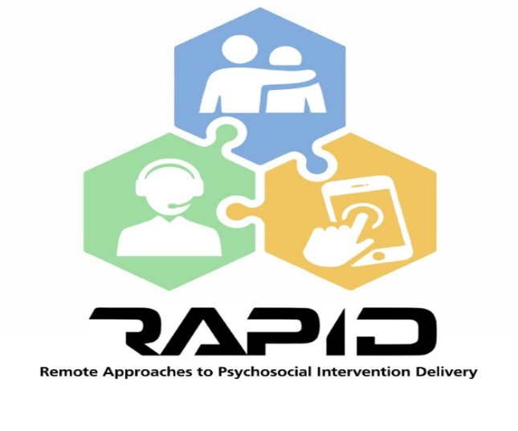

Participant Leaflet v 2.0 26/05/2022 IRAS ID: 307657

[Insert your trust logo here]

**RAPID is a study using online and phone-based psychological support to help prevent psychiatric hospital admissions for those with suicidal thoughts**

People who have thoughts of ending their lives may be likely to be admitted to a psychiatric hospital. However, their admissions can sometimes have a negative impact and may increase their risk of catching COVID-19.

Remote interventions (those delivered online or over the phone) might be a way to improve existing forms of support for people who struggle with suicidal thoughts, as well as making treatment easier to access.

The RAPID trial aims to compare three remote interventions with the standard care people usually receive, to find out how best to help those who experience suicidal thoughts, and if this can reduce admissions to hospital.

**?**

**Why Are We Doing the RAPID Trial?**

**?**

**What Interventions Are We Looking At?**

PREVAIL is delivered via telephone or online over three months by a Peer Support Worker. Peer Support Workers have their own experiences of mental health difficulties. It is based on Cognitive Behavioural Therapy (CBT), a talking therapy which explores the way you think, feel, and behave, and how these are linked.

SAFETEL is a safety planning approach delivered by an Assistant Psychologist via telephone or online. The first meeting involves working together to develop a safety plan, including a list of coping strategies. After this, follow-up calls are offered over three months to check on your wellbeing and review your safety plan.

BrighterSide is a smartphone ap based on CBT which aim to help those with suicidal thinking to understand their thoughts and develop strategies to manage them. In the app, you can choose to complete interactive self-help activities, develop a safety plan, have regular check-ins, and access coping tools. Participants will be supported to access the app via a mobile phone and offered whatever help you might need to use it during the study.

**Meeting the Team**

You will have the chance to discuss the study with a Research Assistant (RA). If you would like to take part, you will be asked to complete a consent form. We will then ask some questions to help us check whether or not this study is right for you. If you are able to take part, you will then be asked to complete several questionnaires and an interview with the RA about your mental health experiences. You will receive £10 for this initial appointment.

**Which study group will I be in?**

You will be asked to take part in one of four groups, either your usual care plus 1) the PREVAIL intervention, 2) the SAFETEL intervention, 3) the BrighterSide Intervention, or 4) your usual care only with no intervention. The group you are in will be decided by chance using a computer, a bit like flipping a coin.

**What does the study involve?**

Everyone in the four groups will be asked to meet again with the RA at 3-months and 6-months following the first meeting. You will be asked some questions about how you’re feeling and will be paid £10 for each time (£30 in total).

* If you are in the PREVAIL group, you will receive up to 12 sessions with a peer support worker over three months, either on Microsoft Teams or via telephone, depending on your preference
* If you are in the SAFETEL group, they will receive up to 12 sessions with an assistant psychologist over three months, either on Microsoft Teams or via telephone, depending on your preference
* If you are in the BrighterSide group, you will be given a smartphone installed with the BrighterSide app. You will have access to the app for six months.

**Regardless of what group you are allocated to, you will be given a phone with a preloaded data plan (that will end after 6 months). You can keep this phone after the trial has ended.**

**What Happens If I Choose to Take Part?**

**?**