

**What is Attention Training Technique?**

Previous research has suggested that people who have experiences of psychosis, such as hearing voices or having beliefs that others do not seem to share or agree with, may have patterns of thinking that significantly pull at their attention. People can get locked into this self-focussed attention which may reinforce and maintain these experiences.

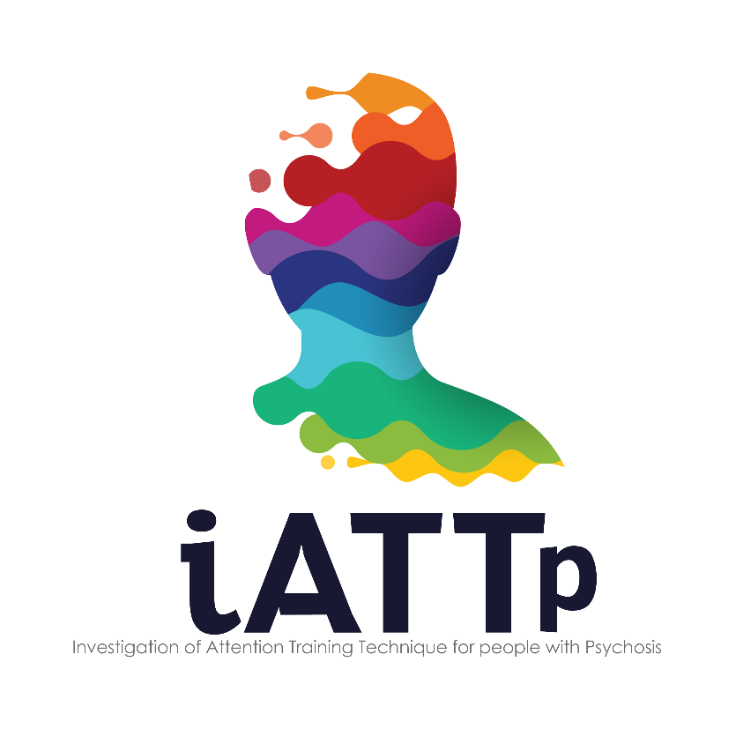

**Do you experience psychosis?**

**Are you in contact with a community mental health service?**

ATT helps a person develop skills in how they select their attention. We know from previous research that ATT can be effective in treating difficulties such as generalised anxiety disorder, posttraumatic stress disorder, obsessive compulsive disorder and depression. ATT could potentially provide advantages for people who experience psychosis but we need to further investigate this to find out.

**Compensation**

In order to compensate you for your time or other expenses we will offer you £20 at each assessment point (i.e. after the initial assessment, and at your 3, 6, and 12 month follow-ups) totalling £80.

**You can leave the study at any time. This will not affect your care.**

**How can I find out more?**

If you would like more information, we are more than happy for you to contact a member of the research team.

**To discuss taking part in this study, please contact:**

**Lydia Pearson** (Research Assistant) on 0161 358 1863 / 07827 903 300

**Sophie Parker** (Consultant Clinical Psychologist) on 0161 358 1395 / 07767 755 790

* Please note that if you decide to take part we will need to inform your care provider (e.g. your GP).

This project is funded by the National Institute for Health Research (NIHR) Research for Patient Benefit (RfPB) Programme (Grant Reference Number PB-PG-1216-20024). The views expressed are those of the authors and not necessarily those of the NIHR, the NHS, or the Department of Health.



You will be randomly allocated to one of two possible outcomes (in research trials these are called treatment ‘arms’):

We are looking for people who experience **psychosis** to take part in a research trial looking at the possible benefits of **Attention Training Technique** (ATT) to help with difficulties associated with psychosis.

Your usual treatment

People in this treatment ‘arm’ will receive their usual treatment meaning that people will remain free to access any other help that’s available through the NHS or other organisations local to them.

Additionally, an iATTp research assistant will meet with you 3 times (3, 6, and 12 months) during the next 12 months for a follow-up assessment appointment.

Participants in previous studies have often told us they find these appointments helpful.

Your usual treatment + ATT

People in this treatment ‘arm’ are offered the Attention Training Technique in addition to their usual treatment / help. The intervention is spread across approximately 12 weekly sessions that last about 30 minutes. This will usually take place in a location convenient to you (e.g. home, clinic or GP surgery).

You will also meet with a research assistant at 3 follow-up points (3, 6, and 12 months)

We will make an appointment with you for an initial assessment with one of our research assistants, which will include completing some questionnaires. After completing the assessment, and if iATTp is suitable for you,

**What is this research about?**

IATTp is a research trial looking at whether ATT is helpful for people who are experiencing psychosis. ATT aims to help a person build skills in selecting their attention

**What will happen if I choose to take part?**

If you are interested in taking part, one of our research assistants will get in touch to discuss the further detail with you. We will provide you with enough information to make an informed decision and answer any questions that you might have. We may also need to talk to someone who already knows you such as a GP, care coordinator or mental health professional to make sure that the **iATTp trial** is suitable for you.

**What are the benefits of taking part in research?**

Research studies like the iATTp trial are important to help develop the best possible help for people experiencing mental health or emotional difficulties. Whether or not you receive therapy in this trial, feedback from previous studies suggests that trial participants often feel good about being part of something that could help provide better care for others in the future.